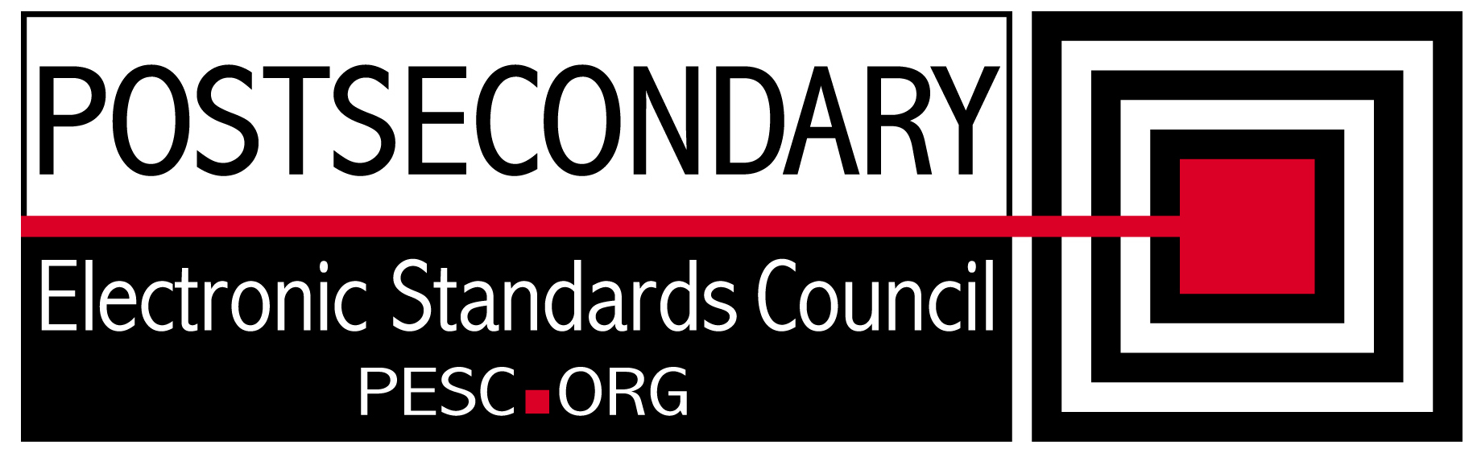

Standards Forum for Education
Status Update Form

Workgroup/Board/Group Name: | Technical Advisory Board
General Summary of Status: | Held several meetings discussing and documenting improvements in Registry and Repository, CDS integration, and XML Architecture.
Status Flag (Red, Yellow, or Green): | Green
Report Date: | 8/13/10
Projected Completion Date: | Standing Board
Item | Responsible Resource | Status
Planned Deliverables/Objectives:  - Component Architecture Approach  - Technical Approach to incorporation of CDS  - SIF Architectural Synchronization | Team, Kumar Shunmuhan  Team  Team | R&R enhancements will be complete 8/29. Requirements for next steps documented  On hold until CDS Implementation team mission clearly defined  Starting analysis
Accomplishments/Completions:
- Provided feedback to Hector Tello on the CDS code list rules
- Developed list of requirements for next generation of XML R&R
- Defined XML architecture differences with SIF schemas
Issues/Obstacles:
- Strategy for architectural integration with CDS, SIFA, and PESC needs clearer definitions and objectives
Assistance Needed:
- Need SIFA representatives to help with discussion of synchronization

Chair(s)/Leader(s) Name(s): | Gideon Sanstra, Michael Morris
Meetings/Calls Since Last Update: | 4

Note: Chairs and/or leaders of workgroups, boards and committees under The Standards Forum for Education are required to provide updates during the Steering Committee’s monthly conference call meeting held the second Friday each month at 2:00pm EST. Call in information is: 866-352-3799 *7696363*. Forms must be completed and submitted prior to meeting time. Forms may also be posted on the PESC website as needed to provide the community at-large with a means to obtain updates for ongoing, but yet to-be-completed development efforts.

